a



Company

Logotype

**Cone Beam Computed Tomography- Report**

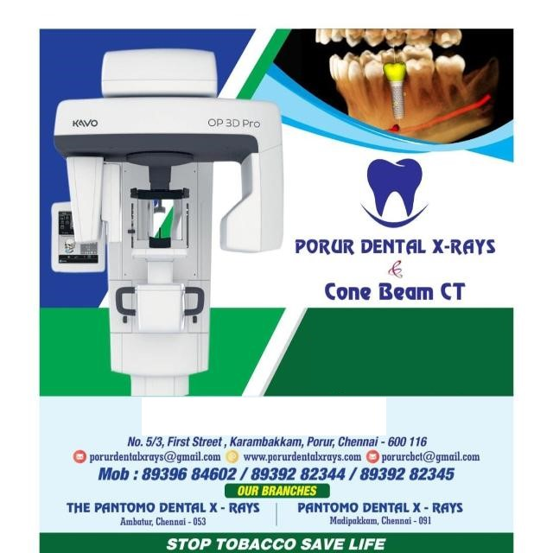



**Porur Dental X-rays & CBCT**

|  |  |
| --- | --- |
| **Patient Name :** Mr. Simiyon | **Date of Report :** 04.06.2024 |
| **Age/ Gender :** 28 years/ Male | **Region of Interest :** CBCT Full Skull |
| **Referring doctor:** Dr. S. M. M. Moulvi | **Indication :** Facial Asymmetry |
| **Clinical Notes:** Nil | |

**PATIENT INFORMATION**

CBCT- Full Skull provided

**CBCT – IMAGE DETAILS**

**RADIOGRAPHIC INTERPRETATION**

* No of teeth present in the maxillary and mandibular arch: 28; Missing teeth: 18, 28, 34, 44.
* Presence of hyperdense orthodontic appliance evident in relation to all teeth.
* The maxillary and mandibular alveolar ridge are present with normal trabecular pattern.
* Presence of hyperdense surgical screws and plates in relation to maxillary, mandibular, nasal and left zygomatic region.
* Deviated nasal septum towards the right side is evident; the right nasal passage appears narrow when compared to the left side.

**RADIOGRAPHIC IMPRESSION**

* Orthodontic appliance- maxillary and mandibular arch
* Deviated nasal septum
* Surgical screws and plates in relation to maxillary, mandibular, nasal and left zygomatic region.

*Kindly correlate with clinical findings*

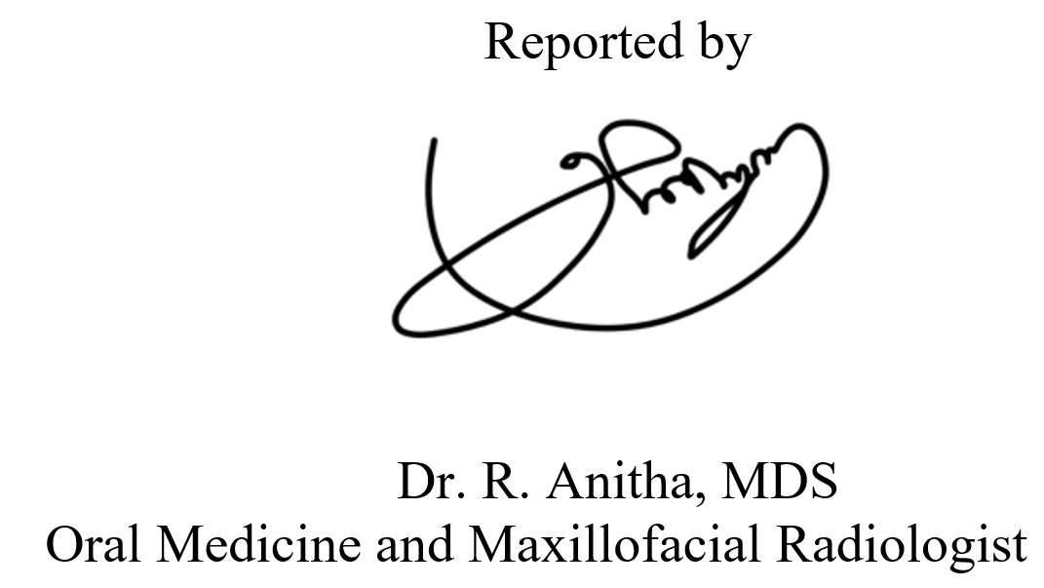

**IMAGES FOR REFERENCE**

**RECONSTRUCTED PANORAMIC VIEW**

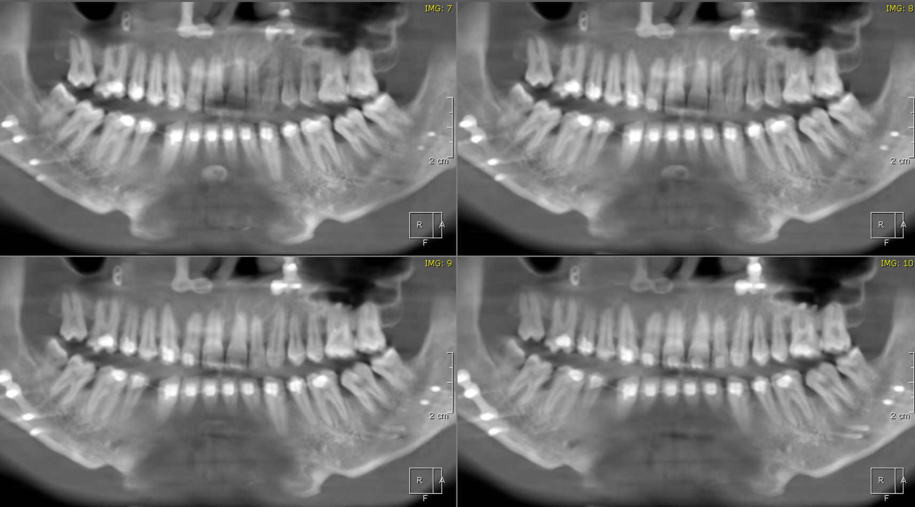

**3-DIMENSIONAL VIEW**

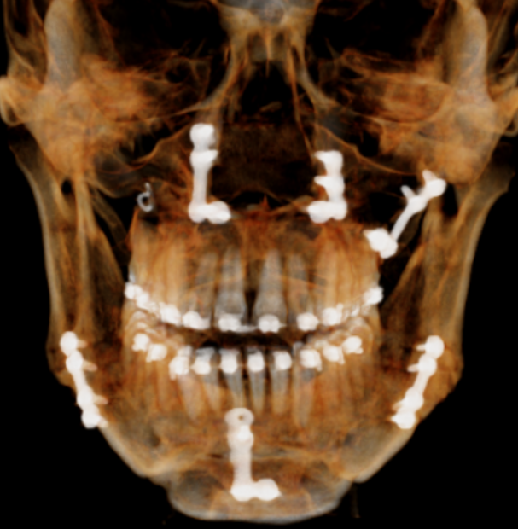

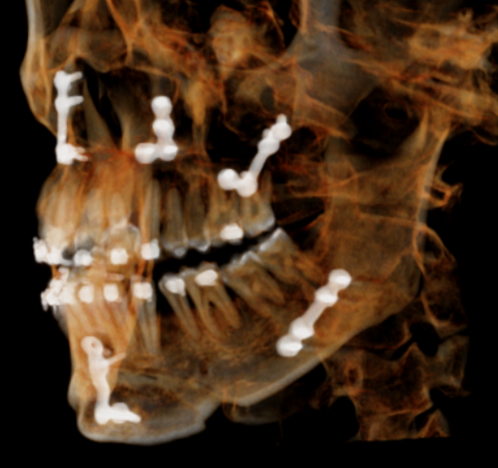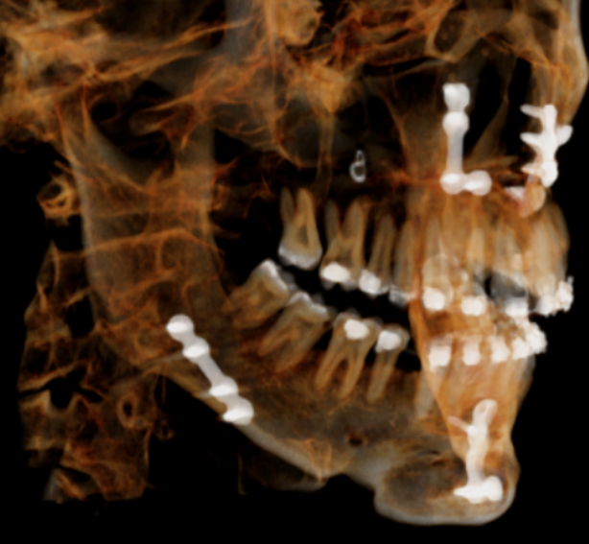

**CORONAL VIEW**

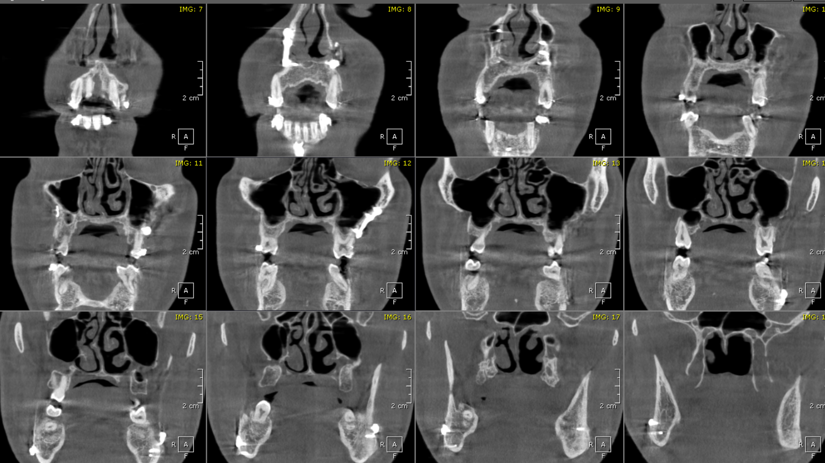

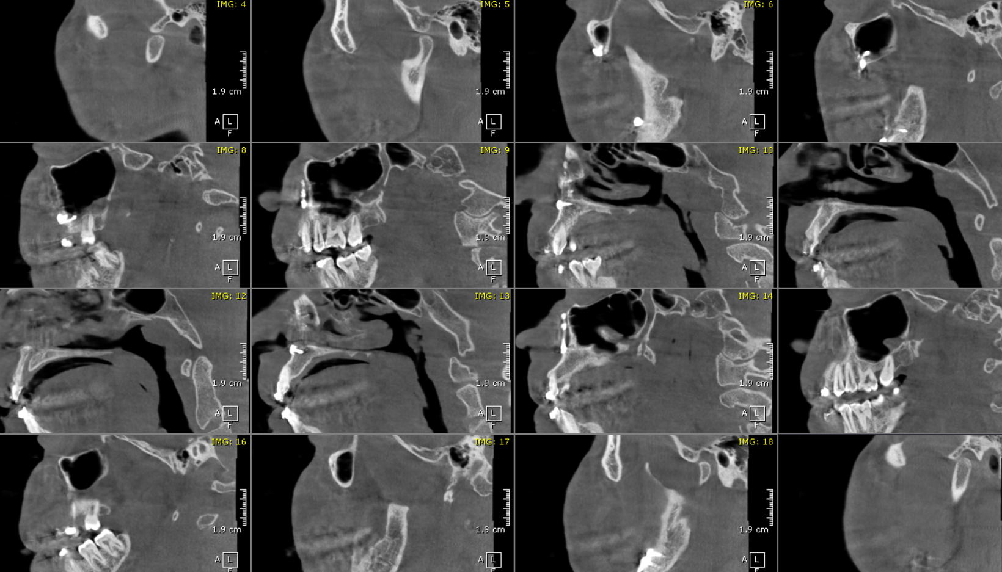 **SAGITTAL VIEW**

**\*\*\* End of report \*\*\*\***